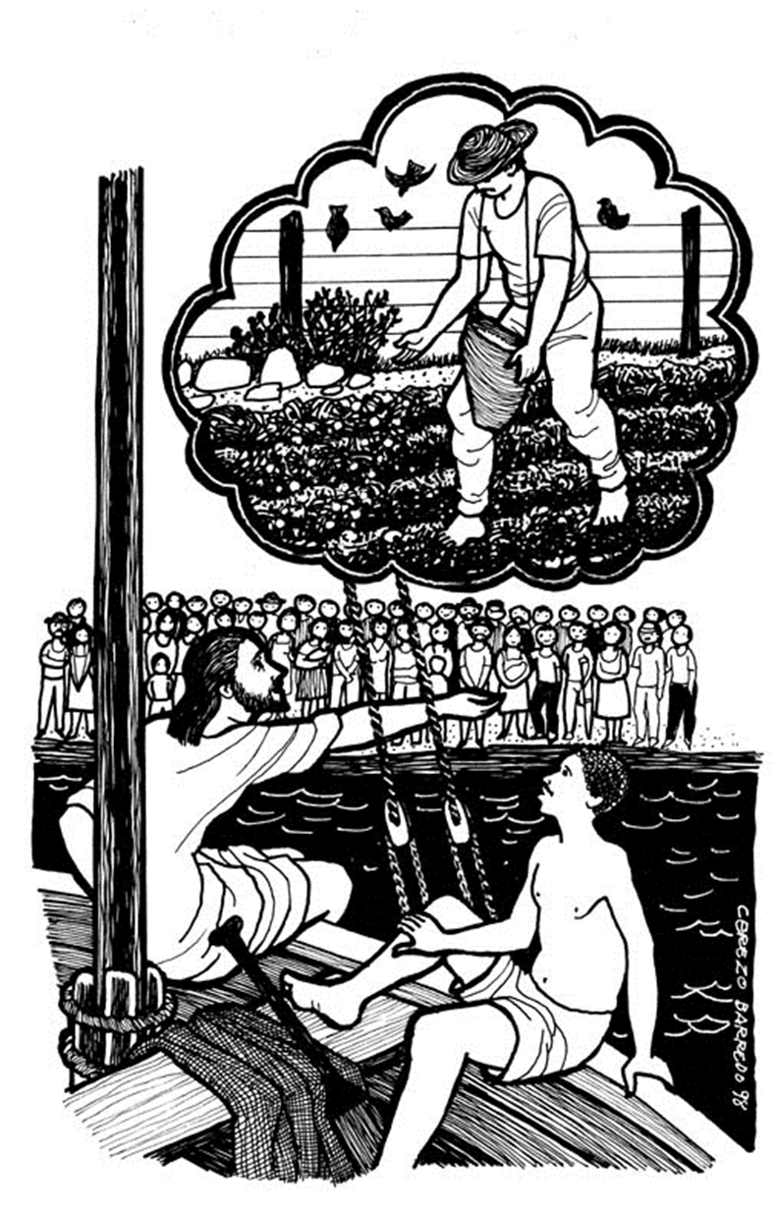

GATHERING SONG “Here I Am, Lord”
“I, the Lord of sea and sky,
I have heard my people cry.
All who dwell in dark and sin
My hand will save.
I, who made the stars of night,
I will make their darkness bright.
Who will bear my light to them?
Whom shall I send?”

Refrain”
Here I am, Lord. Is it I, Lord?
I have heard you calling in the night.
I will go, Lord, if you lead me.
I will hold your people in my heart.

Yo Senior de llivia y sol
las angustias y dolor
de mi pueblo de snar
sin condicion
Ese duro Corazon
Con mi amor transformare.
Quien mi nombre ha de anunciar
Quien me seguira.

Estribillo:
Aqui estor Senior
Heme aqui Senior
En la noche escuche tu voz
Guiame Senior you te seguire.
En mi Corazon, a tue pueblo guardare.

“I, the Lord of snow and rain,
I have borne my people’s pain.
I have wep;t for love of them.
They turn away.
I will break their hearts of stone,
Give them hearts for love alone.
Whom shall I send?”
Refrain”
Here I am, Lord. Is it I, Lord?
I have heard you calling in the night.
I will go, Lord, if you lead me.
I will hold your people in my heart.

“I, the Lord of wind and flame,
I will tend the poor and lame.
I will set a feast for them.
My hand will save.
Finest bread I will provide
Till their hearts be satisfied.
I will give my life to them.
Whom shall I send?”

Refrain”
Here I am, Lord. Is it I, Lord?
I have heard you calling in the night.
I will go, Lord, if you lead me.
I will hold your people in my heart.

CONFESSION AND FORGIVENESS
P: In the Name of the Father, and the Son, + and the Holy Spirit.
C: Amen

P: The Lord sends his Word to us this day. Let us prepare ourselves to be good soil by confessing our sins.

--Silence for Reflection--

P: God of abundant Blessings:
C: You sow your word, and we hear, but we flirt with the evil one and he comes and snatches it away. Lord you sow your word, and we hear, and receive it with joy, but it doesn't take root because our soil is shallow. Lord you sow your Word, and we hear, then we are distracted by the cares of this world, and the lure of money and things grow up around us and choke off what it might yield. Forgive us Lord, continue to sow your Word in our hearts, and bring forth a harvest in us that will bear much fruit. Amen.

P: Hear the good news and let it be planted in our souls: “There is therefore now no condemnation for those who are in Christ Jesus. For the law of the Spirit of life in Christ has set you free from the law of sin and death”. (Romans 8:1-2). In the name of Jesus Christ your sins are forgiven! Through the peace and gratitude sown in our hearts, we say:
C: Thanks be to God!

GREETING
A: God abundantly casts seeds of good news upon us.
C: May we be the good soil, getting ready for the sowing of God’s word and God’s love.
All: May we bear much good fruit to love God and serve our neighbor!

PRAYER OF THE DAY
Most wonderful God, you have sown in us a seed which longs to put down deep roots and then grow towards your light. By your Spirit please tend and nurture that which you have planted, that in spite of hard seasons or the work of evil predators, we may bring forth a harvest of wonder, love and praise. Through Jesus Christ, the sower of the kingdom. Amen!

FIRST READING: Isaiah 55:10-13
¹⁰For as the rain and the snow come down from heaven, and do not return there until they have watered the earth, making it bring forth and sprout, giving seed to the sower and bread to the eater, ¹¹so shall my word be that goes out from my mouth; it shall not return to me empty, but it shall accomplish that which I purpose, and succeed in the thing for which I sent it. ¹²For you shall go out in joy, and be led back in peace; the mountains and the hills before you shall burst into song, and all the trees of the field shall clap their hands. ¹³Instead of the thorn shall come up the cypress; instead of the brier shall come up the myrtle; and it shall be to the LORD for a memorial, for an everlasting sign that shall not be cut off.
Word of God, Word of Life.
C: Thanks be to God!

HYMN OF PREPARATION “Lord, Let My Heart Be Good Soil”

Lord let my heart be good soil, open to the seed of your word.
Lord let my heart be good soil, where love can grow and peace is understood.
When my heart is hard, break the stone away.
When my heart is cold, warm it with the day.
When my heart is lost, lead me on your way,
Lord, let my heart, Lord let my heart, Lord, let my heart be good soil.

GOSPEL: Matthew 13:1-9, 18-23
¹That same day Jesus went out of the house and sat beside the sea. ²Such great crowds gathered around him that he got into a boat and sat there, while the whole crowd stood on the beach. ³And he told them many things in parables, saying: "Listen! A sower went out to sow. ⁴And as he sowed, some seeds fell on the path, and the birds came and ate them up. ⁵Other seeds fell on rocky ground, where they did not have much soil, and they sprang up quickly, since they had no depth of soil. ⁶But when the sun rose, they were scorched; and since they had no root, they withered away. ⁷Other seeds fell among thorns, and the thorns grew up and choked them. ⁸Other seeds fell on good soil and brought forth grain, some a hundredfold, some sixty, some thirty. ⁹Let anyone with ears listen!"

¹⁸"Hear then the parable of the sower. ¹⁹When anyone hears the word of the kingdom and does not understand it, the evil one comes and snatches away what is sown in the heart; this is what was sown on the path. ²⁰As for what was sown on rocky ground, this is the one who hears the word and immediately receives it with joy; ²¹yet such a person has no root, but endures only for a while, and when trouble or persecution arises on account of the word, that person immediately falls away. ²²As for what was sown among thorns, this is the one who hears the word, but the cares of the world and the lure of wealth choke the word, and it yields nothing. ²³But as for what was sown on good soil, this is the one who hears the word and understands it, who indeed bears fruit and yields, in one case a hundredfold, in another sixty, and in another thirty."

This is the Gospel of the Lord

SERMON “Slinging Seed”

SPECIAL MUSIC “Who Am I?” Sung by: Debby Brady

APOSTLE’S CREED
C: I believe in God, the Father almighty,
creator of heaven and earth.

I believe in Jesus Christ, his only Son, our Lord.
He was conceived by the power of the Holy Spirit
and born of the virgin Mary.
He suffered under Pontius Pilate,
was crucified, died, and was buried.
He descended into hell.*
On the third day he rose again.
He ascended into heaven,
and is seated at the right hand of the Father.
He will come again to judge the living and the dead.

I believe in the Holy Spirit,
the holy catholic Church,
the communion of saints,
the forgiveness of sins,
the resurrection of the body,
and the life everlasting. Amen

Credo Apostolico
Creo en Dios Padre Todopoderoso, Creador del cielo y de la tierra; y en Jesucristo, su único Hijo, Señor nuestro; que fue concebido del Espíritu Santo, nació de la virgen María, padeció bajo el poder de Poncio Pilatos; fue crucificado, muerto y sepultado; descendió a los infiernos; al tercer día resucitó de entre los muertos; subió al cielo, y está sentado a la diestra de Dios Padre Todopoderoso; y desde allí vendrá al fin del mundo a juzgar a los vivos y a los muertos.
Creo en el Espíritu Santo, la Santa Iglesia Catolica, la comunión de los santos, el perdón de los pecados, la resurrección de la carne y la vida perdurable. Amén.

THE PRAYERS OF THE CHURCH
A: Sower of seed,
C: produce good fruit.

THE PEACE
PEACE
P: The peace of the Lord be with you always.
C: And also with you.

CELEBRATION OF EUCHARIST

P: In the night in which he was betrayed,
our Lord Jesus took bread, and gave thanks;
broke it, and gave it to his disciples, saying:
Take and eat; this is my body, given for you.
Do this in remembrance of me.

P: Again, after supper, he took the cup, gave thanks, and gave it for all to drink, saying: This cup is the new covenant in my blood, shed for you and for all people for the forgiveness of sin. Do this in remembrance of me.

THE LORD’S PRAYER
C: Our Father, who art in heaven,
hallowed be thy name,
thy kingdom come,
thy will be done,
on earth as it is in heaven.
Give us this day our daily bread;
and forgive us our trespasses,
as we forgive those who trespass against us;
and lead us not into temptation,
but deliver us from evil.
as we forgive those who trespass against us;
and lead us not into temptation,
but deliver us from evil.
For thine is the kingdom, and the power, and the glory forever. Amen.

Padre Nuestro
Padre nuestro, que estas en los cielos, santificado sea tu nombre;
Venga a nos tu reino; hágase tu voluntad, así en la tierra como en el cielo;
El pan nuestro de cada día, dánoslo hoy;
y perdónanos nuestras deudas así como nosotros perdonamos a nuestros deudores;
y no nos dejes caer en la tentación; mas líbranos del mal.
Porque tuyo es el reino, el poder y la gloria, por los siglos de los siglos. Amén.

PRAYER OF COMMITMENT
P: God of harvest, gardener supreme, you place us at the center;
C: feed us, equip us and, having provided for us,
look to a different harvest—
a fruitfulness of lives in service to you and others.
God of harvest,
feed us, prune us, harvest us, that our lives
might bring glory to you.
Amen.

BLESSING AND SENDING

P: May God the sower
make you good and fertile soil.
May Christ the seed
bloom and grow in your words and actions.
May the fruitful Spirit
bring forth a bountiful yield in your lives.
God the Father, + Son, and Holy Spirit
bless you now and forever.
C: Amen.

CLOSING HYMN “Open The Eyes of My Heart Lord”
To see You high and lifted up
Shinin' in the light of Your glory
Pour out Your power and love
As we sing holy, holy, holy
Chorus:
Open the eyes of my heart, Lord,
Open the eyes of my heart;
I want to see You, I want to see You
Abre mis ojos Oh Cristo
Abris mis ojos Senior
Yo quiero verte, Yo quiero verte.

To see You high and lifted up
Shinin' in the light of Your glory
Pour out Your power and love
As we sing holy, holy, holy
Bridge:
Holy, Holy, Holy,
Holy, Holy, Holy,
Holy, Holy, Holy,
I want to see you.

Santo, Santo, Santo,
Santo, Santo, Santo,
Santo, Santo, Santo
You quiero verte.

Chorus:
Open the eyes of my heart, Lord,
Open the eyes of my heart;
I want to see You, I want to see You
Abre mis ojos Oh Cristo
Abris mis ojos Senior
Yo quiero verte, Yo quiero verte.

