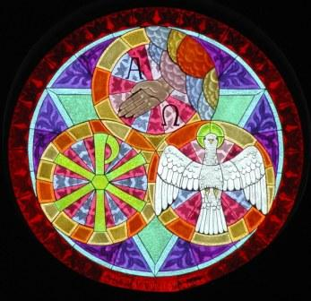

OPENING SONG Holy, Holy, Holy a new arrangement by Pam Asberry
Holy, holy, holy!
Lord God Almighty
Early in the morning
Our song shall rise to Thee
Holy, holy, holy!
Merciful and mighty
God in three persons
Blessed Trinity!
Holy, holy, holy!
Though the darkness hide thee
Though the eye of sinful man
Thy glory may not see
Only Thou art holy
There is none beside Thee
Perfect in power, in love and purity
Holy, holy, holy! Lord God Almighty!
All Thy works shall praise Thy name in earth and sky and sea;
Holy, holy, holy, merciful and mighty!
God in three Persons, blessed Trinity!
CONFESSION AND FORGIVENESS

P: In the Name of the Father, and the Son, + and the Holy Spirit.
C: Amen

P: Let us be honest with our God, the maker of all things.

--Silence for Reflection--

P: Loving God...
C: by speaking you create all that is
and give order and goodness to the universe.
You have entrusted your creation to us,
that we should protect, sustain and nourish it;
yet we take your command to have dominion
and subdue as license to exploit creation
and do what we wish.
Your Son commissioned us to go, teach and baptize,
but we would rather stay and wait for people to come seeking us
and then we will share our wisdom and fellowship with them.
Forgive us, Lord, for placing our own appetites
and comforts above the needs of our neighbors,
and all the living creatures with which we share this planet. Amen.

P: Again hear the good news, in the name of the Father who created you,
Jesus Christ the Son of God who redeemed you from your sins,
and the Holy Spirit who sustains your faith and life, your sins are forgiven!
If you are in Christ then you have been made a new creation, the old has passed away, and new life begins.
C: Amen!

GREETING
A: The grace of our Lord Jesus Christ, the love of God, + and the communion of the Holy Spirit be with you all.
C: And also with you.
PRAYER OF THE DAY
P: Let us pray. God of heaven and earth,
C: before the foundation of the universe and the beginning of time you are the triune God: Author of creation, eternal Word of salvation, life-giving Spirit of wisdom. Guide us to all truth by your Spirit that we may proclaim all that Christ has revealed and rejoice in the glory he shares with us. Glory and praise to you, Father, Son, and Holy Spirit, now and forever. Amen.

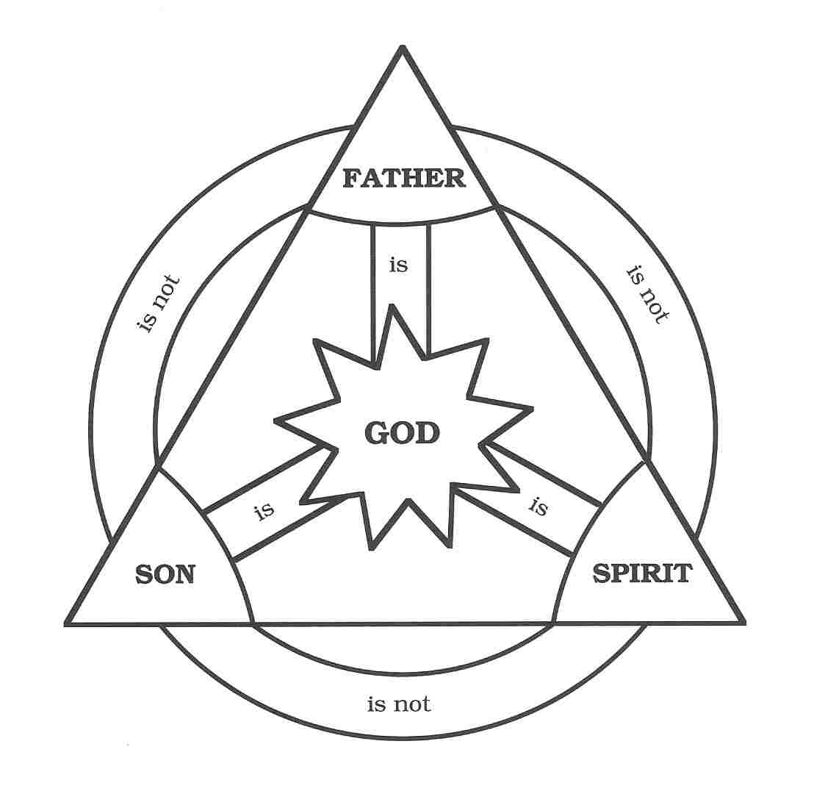

FIRST READING: Genesis 1:1--2:4a
A reading from Genesis.
1 In the beginning when God created the heavens and the earth, 2 the earth was a formless void and darkness covered the face of the deep, while a wind from God swept over the face of the waters. 3 Then God said, “Let there be light”; and there was light. 4 And God saw that the light was good; and God separated the light from the darkness. 5 God called the light Day, and the darkness God called Night. And there was evening and there was morning, the first day. 6 And God said, “Let there be a dome in the midst of the waters, and let it separate the waters from the waters.” 7 So God made the dome and separated the waters that were under the dome from the waters that were above the dome. And it was so. 8 God called the dome Sky. And there was evening and there was morning, the second day. 9 And God said, “Let the waters under the sky be gathered together into one place, and let the dry land appear.” And it was so. 10God called the dry land Earth, and the waters that were gathered together God called Seas. And God saw that it was good. 11Then God said, “Let the earth put forth vegetation: plants yielding seed, and fruit trees of every kind on earth that bear fruit with the seed in it.” And it was so. 12The earth brought forth vegetation: plants yielding seed of every kind, and trees of every kind bearing fruit with the seed in it. And God saw that it was good. 13And there was evening and there was morning, the third day. 14And God said, “Let there be lights in the dome of the sky to separate the day from the night; and let them be for signs and for seasons and for days and years, 15and let them be lights in the dome of the sky to give light upon the earth.” And it was so. 16God made the two great lights— the greater light to rule the day and the lesser light to rule the night—and the stars. 17God set them in the dome of the sky to give light upon the earth, 18to rule over the day and over the night, and to separate the light from the darkness. And God saw that it was good. 19And there was evening and there was morning, the fourth day. 20And God said, “Let the waters bring forth swarms of living creatures, and let birds fly above the earth across the dome of the sky.” 21So God created the great sea monsters and every living creature that moves, of every kind, with which the waters swarm, and every winged bird of every kind. And God saw that it was good. 22God blessed them, saying, “Be fruitful and multiply and fill the waters in the seas, and let birds multiply on the earth.” 23And there was evening and there was morning, the fifth day. 24And God said, “Let the earth bring forth living creatures of every kind: cattle and creeping things and wild animals of the earth of every kind.” And it was so. 25God made the wild animals of the earth of every kind, and the cattle of every kind, and everything that creeps upon the ground of every kind. And God saw that it was good. 26Then God said, “Let us make humankind in our image, according to our likeness; and let them have dominion over the fish of the sea, and over the birds of the air, and over the cattle, and over all the wild animals of the earth, and over every creeping thing that creeps upon the earth.” 27So God created humankind in the divine image, in the image of God humankind was created; male and female God created them. 28God blessed them, and God said to them, “Be fruitful and multiply, and fill the earth and subdue it; and have dominion over the fish of the sea and over the birds of the air and over every living thing that moves upon the earth.” 29God said, “See, I have given you every plant yielding seed that is upon the face of all the earth, and every tree with seed in its fruit; you shall have them for food. 30And to every beast of the earth, and to every bird of the air, and to everything 3 that creeps on the earth, everything that has the breath of life, I have given every green plant for food.” And it was so. 31God saw everything that had been made, and indeed, it was very good. And there was evening and there was morning, the sixth day. 2:1Thus the heavens and the earth were finished, and all their multitude. 2 And on the seventh day God finished the work that had been done, and God rested on the seventh day from all the work that had been done. 3 So God blessed the seventh day and hallowed it, because on it God rested from all the work that God had done in creation. 4aThese are the generations of the heavens and the earth when they were created.
Word of God, word of life.
C: Thanks be to God!

GOSPEL: Matthew 28:16-20
16Now the eleven disciples went to Galilee, to the mountain to which Jesus had directed them. 17When they saw Jesus, they worshiped him; but some doubted. 18And Jesus came and said to them, “All authority in heaven and on earth has been given to me. 19Go therefore and make disciples of all nations, baptizing them in the name of the Father and of the Son and of the Holy Spirit, 20and teaching them to obey everything that I have commanded you. And remember, I am with you always, to the end of the age.”
The gospel of the Lord.
C: Praise to you, O Christ.
CHILDREN’S MESSAGE
SERMON “Big”

SOLO Give Me Jesus African American Spiritual, arr.Fleming
Lois Simon, soloist with Rick Simon, guitar
APOSTLES CREED

C I believe in God, the Father almighty,
creator of heaven and earth.

I believe in Jesus Christ, his only Son, our Lord.
He was conceived by the power of the Holy Spirit
and born of the virgin Mary.
He suffered under Pontius Pilate,
was crucified, died, and was buried.
He descended into hell.*
On the third day he rose again.
He ascended into heaven,
and is seated at the right hand of the Father.
He will come again to judge the living and the dead.

I believe in the Holy Spirit,
the holy catholic Church,
the communion of saints,
the forgiveness of sins,
the resurrection of the body,
and the life everlasting. Amen

THE PRAYERS OF THE CHURCH

L In confidence we pray to the Father, through the Son, in the Holy Spirit, saying: Holy, Holy, Holy, Lord,
C: Blessed Trinity.

PEACE
P: The peace of the Lord be with you always.
C And also with you.

CELEBRATION OF EUCHARIST

In the night in which he was betrayed,
our Lord Jesus took bread, and gave thanks;
broke it, and gave it to his disciples, saying:
Take and eat; this is my body, given for you.
Do this in remembrance of me.

Again, after supper, he took the cup, gave thanks, and gave it for all to drink, saying: This cup is the new covenant in my blood, shed for you and for all people for the forgiveness of sin. Do this in remembrance of me.

THE LORD’S PRAYER
C Our Father, who art in heaven,
hallowed be thy name,
thy kingdom come,
thy will be done,
on earth as it is in heaven.
Give us this day our daily bread;
and forgive us our trespasses,
as we forgive those who trespass against us;
and lead us not into temptation,
but deliver us from evil.
For thine is the kingdom, and the power, and the glory,
forever and ever. Amen

P: The body and blood of our Lord Jesus Christ
strengthen you and keep you in his grace.
C: Amen.

POST COMMUNION PRAYER

P: God, our Creator:
C: At this table you have satisfied us
with gifts of your Son’s Body and Blood.
Fill our hearts with the Spirit of Truth and
make us bearers of truth for all needy souls.
In the name of the Father, and of the Son and of the Holy Spirit.
Amen

BLESSING

P: Go out into the world and live in peace.
Bear witness to the God of love and peace,
and make disciples of all nations,
teaching them to obey all that Christ has taught.
P: And may God look upon you and take delight in you;
May Christ Jesus be with you always, to the end of the age;
And may the Holy Spirit lead you into the dance of love
that is the life of the Trinity.
C: AMEN

CONCLUDING SONG You Are Holy ELW 525
You are holy, you are whole.
You are always ever more than we ever understand.
You are always at hand.
Blessed are you coming near;
blessed are you coming here
to your church in wine and bread,
raised from soil, raised from dead.
You are holy, you are wholeness, you are present,
let the cosmos praise you Lord!
Sing hosanna in the highest!
Sing hosanna! Sing hosanna to our God!

