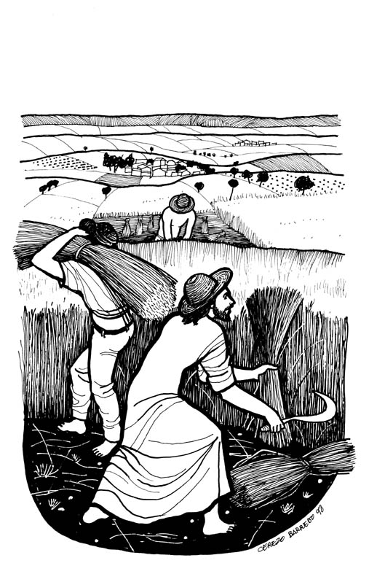

OPENING SONG “Here I Am, Lord”
I, the Lord of sea and sky
I have heard my people cry
All who dwell in dark and sin
My hand will save
I, who made the stars of night
I will make their darkness bright
Who will bear my light to them?
Whom shall I send?
Here I am, Lord. Is it I, Lord?
I have heard you calling in the night
I will go, Lord, if you lead me
I will hold your people in my heart
I, the Lord of snow and rain
I have borne my people's pain
I have wept for love of them
They turn away
I will break their hearts of stone
Give them hearts for love alone
I will speak my words to them
Whom shall I send?
Here I am, Lord. Is it I, Lord?
I have heard you calling in the night
I will go, Lord, if you lead me
I will hold your people in my heart
[Verse 5]
I, the Lord of wind and flame
I will tend the poor and lame
I will set a feast for them
My hand will save
Finest bread I will provide
'Til their hearts be satisfied
I will give my life to them
Whom shall I send?

Here I am, Lord. Is it I, Lord?
I have heard you calling in the night
I will go, Lord, if you lead me
I will hold your people in my heart
CONFESSION AND FORGIVENESS
P: God offers us the hospitality of his table and invites us to confess our sins before God and one another.

--Silence for Reflection--

P: Lord Jesus,
C You are the shepherd and we are your flock,
but we admit the times we have tried to take your place
and take control ourselves.
We confess that we have not always trusted
your good news to be good for us.
At times we have pleaded with you to care for us,
but we have held back from caring for others
and ignored the needs of others.
Lord, have mercy upon us.
Forgive us in the name of Jesus.
Loving shepherd,
teach us by the Holy Spirit to follow You
in the days and places of the weeks ahead.
Through Jesus Christ we pray, Amen.

P: Hear this good news from Paul’s letter to the Romans: “While we were still weak, at the right time Christ died for the ungodly. Since we are justified by faith, we now have peace with God through our Lord Jesus Christ, through whom we have obtained access to God’s grace in which we now stand.” In the name of Jesus, the Lord of the Harvest, you are forgiven! Live in God’s peace!
C: Amen! Thanks be to God!

GREETING
A: Lord Jesus, you call us ordinary as we are.
C: Unprepared as we are, you call us to be your disciples.
A: You give us authority to speak for you, O Christ.
C: But we do not know what to say.
A: Teach us what to do and say, to serve our neighbors faithfully in your name.
C: For now we answer your call to worship you this day!

PRAYER OF THE DAY
Most loving God, you call not only the very gifted people
but common folk like us to be Christ’s disciples and to share
the good news. Please govern our unruly self-serving and
rebellious attitudes, that with a singular devotion to you we
may be your heralds in a world longing for much better news
than that which fascinates and saturates the media.
Through Christ Jesus, the compassionate Shepherd, Amen.

FIRST READING: Exodus 19:2-8
²They had journeyed from Rephidim, entered the wilderness of Sinai, and camped in the wilderness; Israel camped there in front of the mountain. ³Then Moses went up to God; the Lord called to him from the mountain, saying, “Thus you shall say to the house of Jacob, and tell the Israelites: ⁴You have seen what I did to the Egyptians, and how I bore you on eagles’ wings and brought you to myself. ⁵Now therefore, if you obey my voice and keep my covenant, you shall be my treasured possession out of all the peoples. Indeed, the whole earth is mine, ⁶but you shall be for me a priestly kingdom and a holy nation. These are the words that you shall speak to the Israelites.” ⁷So Moses came, summoned the elders of the people, and set before them all these words that the Lord had commanded him. ⁸The people all answered as one: “Everything that the Lord has spoken we will do.” Moses reported the words of the people to the Lord.
Word of God, Word of Life.
C: Thanks be to God

GOSPEL READING: Matthew 9:35-10:20
³⁵Jesus went about all the cities and villages, teaching in their synagogues, and proclaiming the good news of the kingdom, and curing every disease and every sickness. ³⁶When he saw the crowds, he had compassion for them, because they were harassed and helpless, like sheep without a shepherd. ³⁷Then he said to his disciples, "The harvest is plentiful, but the laborers are few; ³⁸therefore ask the Lord of the harvest to send out laborers into his harvest." ^{10:1}Then Jesus summoned his twelve disciples and gave them authority over unclean spirits, to cast them out, and to cure every disease and every sickness.
²These are the names of the twelve apostles: first, Simon, also known as Peter, and his brother Andrew; James son of Zebedee, and his brother John; ³Philip and Bartholomew; Thomas and Matthew the tax collector; James son of Alphaeus, and Thaddaeus; ⁴Simon the Cananaean, and Judas Iscariot, the one who betrayed him.
⁵These twelve Jesus sent out with the following instructions: "Go nowhere among the Gentiles, and enter no town of the Samaritans, ⁶but go rather to the lost sheep of the house of Israel. ⁷As you go, proclaim the good news, 'The kingdom of heaven has come near.' ⁸Cure the sick, raise the dead, cleanse the lepers, cast out demons. You received without payment; give without payment. [⁹Take no gold, or silver, or copper in your belts, ¹⁰no bag for your journey, or two tunics, or sandals, or a staff; for laborers deserve their food. ¹¹Whatever town or village you enter, find out who in it is worthy, and stay there until you leave. ¹²As you enter the house, greet it. ¹³If the house is worthy, let your peace come upon it; but if it is not worthy, let your peace return to you. ¹⁴If anyone will not welcome you or listen to your words, shake off the dust from your feet as you leave that house or town. ¹⁵Truly I tell you, it will be more tolerable for the land of Sodom and Gomorrah on the day of judgment than for that town.
¹⁶"See, I am sending you out like sheep into the midst of wolves; so be wise as serpents and innocent as doves. ¹⁷Beware of them, for they will hand you over to councils and flog you in their synagogues; ¹⁸and you will be dragged before governors and kings because of me, as a testimony to them and the Gentiles. ¹⁹When they hand you over, do not worry about how you are to speak or what you are to say; for what you are to say will be given to you at that time; ²⁰for it is not you who speak, but the Spirit of your Father speaking through you.
The Gospel of the Lord!
C: Praise to you, O Christ!

CHILDREN’S MESSAGE

SERMON “Field Hands”

SPECIAL MUSIC Knowing You Graham Kendric
David and Kathy Berfield, soloists

THE APOSTLE’S CREED
C: I believe in God, the Father almighty,
creator of heaven and earth.

I believe in Jesus Christ, his only Son, our Lord.
He was conceived by the power of the Holy Spirit
and born of the virgin Mary.
He suffered under Pontius Pilate,
was crucified, died, and was buried.
He descended into hell.*
On the third day he rose again.
He ascended into heaven,
and is seated at the right hand of the Father.
He will come again to judge the living and the dead.

I believe in the Holy Spirit,
the holy catholic Church,
the communion of saints,
the forgiveness of sins,
the resurrection of the body,
and the life everlasting. Amen

THE PRAYER’S OF THE CHURCH
God of compassion,
C: Hear our prayer

THE PEACE
P: The peace of the Lord be with you always.
C And also with you.

CELEBRATION OF EUCHARIST

P: In the night in which he was betrayed,
our Lord Jesus took bread, and gave thanks;
broke it, and gave it to his disciples, saying:
Take and eat; this is my body, given for you.
Do this in remembrance of me.

P: Again, after supper, he took the cup, gave thanks, and gave it for all to drink, saying: This cup is the new covenant in my blood, shed for you and for all people for the forgiveness of sin. Do this in remembrance of me.

THE LORD’S PRAYER
C: Our Father, who art in heaven,
hallowed be thy name,
thy kingdom come,
thy will be done,
on earth as it is in heaven.
Give us this day our daily bread;
and forgive us our trespasses,
as we forgive those who trespass against us;
and lead us not into temptation,
but deliver us from evil.
For thine is the kingdom, and the power, and the glory,
forever and ever. Amen

P: The body and blood of our Lord Jesus Christ, strengthen you and keep you in his grace.
C: Amen

PRAYER OF COMMITMENT

P God of harvest, gardener supreme,
C: you place us at the center, feed us, equip us and,
having provided for us, look to a different harvest—
a fruitfulness of lives in service to you and others.
God of harvest, feed us, prune us, harvest us, that our lives might bring glory to you. Amen.

BLESSING AND SENDING

P: The Lord seeks willing laborers for the harvest.
Therefore go out into the world,
proclaim the good news of the nearness of God;
and call all who will hear to wholeness,
to life, to holiness.
P: And may God pour love into your hearts;
May Christ Jesus open the way of grace to you;
and may the Holy Spirit work through all things
to build you up in endurance, character and hope.
C: Amen.

CLOSING HYMN “Will You Come and Follow Me”
Will You Come And Follow Me
If I But Call Your Name?
Will You Go Where You Don’t Know
And Never Be The Same?
Will You Let My Love Be Shown,
Will You Let My Name Be Known,
Will You Let My Life Be Grown
In You And You In Me?
Will You Leave Yourself Behind
If I But Call Your Name?
Will You Care For Cruel And Kind
And Never Be The Same?
Will You Risk The Hostile Stare
Should Your Life Attract Or Scare?
Will You Let Me Answer Prayer
In You And You In Me?
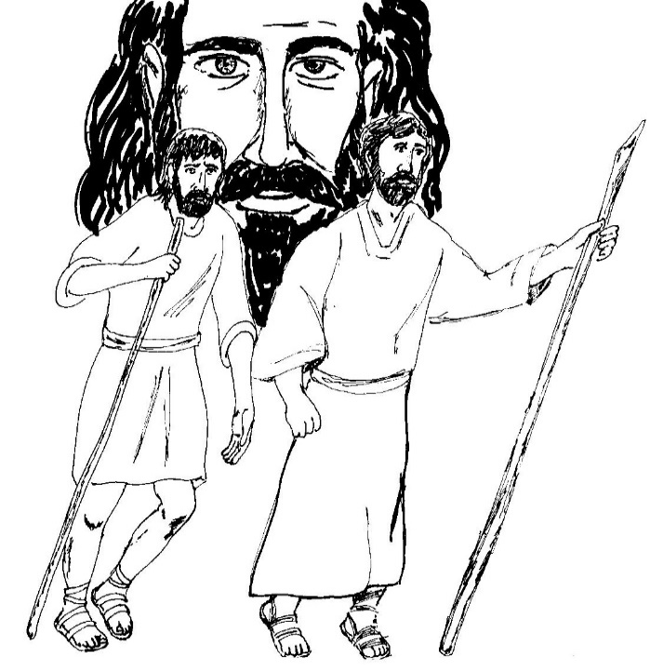
Will You Let The Blinded See
If I But Call Your Name?
Will You Set The Prisoners Free
And Never Be The Same?
Will You Kiss The Leper Clean,
And Do Such As This Unseen,
And Admit To What I Mean
In You And You In Me?
Will You Love The ‘You’ You Hide
If I But Call Your Name?
Will You Quell The Fear Inside
And Never Be The Same?
Will You Use The Faith You’ve Found
To Reshape The World Around,
Through My Sight And Touch And Sound
In You And You In Me?
Lord, Your Summons Echoes True
When You But Call My Name.
Let Me Turn And Follow You
And Never Be The Same.
In Your Company I’ll Go
Where Your Love And Footsteps Show.
Thus I’ll Move And Live And Grow
In You And You In Me.

