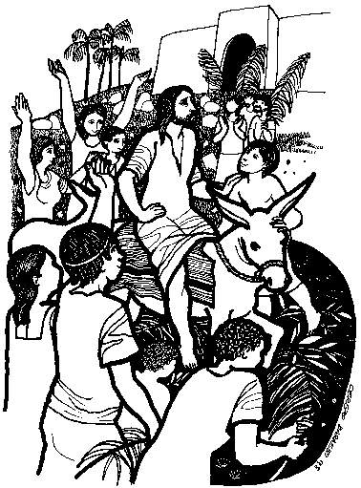

PALM SUNDAY GREETING
P: Wave your branches high. Jesus is coming!
C: Blessed is the one who comes in the name of the Lord!
P: Open wide your hearts.
C: Let the Savior enter.
P: Spread your garments on his path.
C: Prepare the way for the salvation of our God. Hosanna!

PRAYER OF THE DAY
P: Let us pray: Blessed are you, Holy God,

C: For in Jesus Christ you came to rule in our lives, not as a king, but as a humble servant, riding on a donkey. Enter into our hearts this day with your glory, that we may greet you with shouts of praise; through Christ, our Savior, who died and rose, who lives and reigns, with you and the Holy Spirit, one God, now and forever. Amen.

FIRST READING: Isaiah 50:4-9

⁴The Lord God has given me the tongue of a teacher, that I may know how to sustain the weary with a word. Morning by morning he wakens— wakens my ear to listen as those who are taught. ⁵The Lord God has opened my ear, and I was not rebellious, I did not turn backward. ⁶I gave my back to those who struck me, and my cheeks to those who pulled out the beard; I did not hide my face from insult and spitting. ⁷The Lord God helps me; therefore I have not been disgraced; therefore I have set my face like flint, and I know that I shall not be put to shame; ⁸he who vindicates me is near. Who will contend with me? Let us stand up together. Who are my adversaries? Let them confront me. ⁹It is the Lord God who helps me; who will declare me guilty? All of them will wear out like a garment; the moth will eat them up.
Word of God, Word of Life!
C: Thanks be to God!

Isaías 50:4-9
⁴ El Señor omnipotente me ha concedido
tener una lengua instruida,
para sostener con mi palabra al fatigado.
Todas las mañanas me despierta,
y también me despierta el oído,
para que escuche como los discípulos.
⁵ El Señor omnipotente me ha abierto los oídos,
y no he sido rebelde ni me he vuelto atrás.
⁶ Ofrecí mi espalda a los que me golpeaban,
mis mejillas a los que me arrancaban la barba;
ante las burlas y los escupitajos
no escondí mi rostro.
⁷ Por cuanto el Señor omnipotente me ayuda,
no seré humillado.
Por eso endurecí mi rostro como el pedernal,
y sé que no seré avergonzado.
⁸ Cercano está el que me justifica;
¿quién entonces contenderá conmigo?
¡Comparezcamos juntos!
¿Quién es mi acusador?
¡Que se me enfrente!
⁹ ¡El Señor omnipotente es quien me ayuda!
¿Quién me condenará?
Todos ellos se gastarán;
como a la ropa, la polilla se los comerá.

GOSPEL: Matthew 21:1-11
When they had come near Jerusalem and had reached Bethphage, at the Mount of Olives, Jesus sent two disciples, 2 saying to them, "Go into the village ahead of you, and immediately you will find a donkey tied, and a colt with her; untie them and bring them to me. 3 If anyone says anything to you, just say this, 'The Lord needs them.' And he will send them immediately." 4 This took place to fulfill what had been spoken through the prophet, saying, 5 "Tell the daughter of Zion, Look, your king is coming to you, humble, and mounted on a donkey, and on a colt, the foal of a donkey." 6 The disciples went and did as Jesus had directed them; 7 they brought the donkey and the colt, and put their cloaks on them, and he sat on them. 8A very large crowd spread their cloaks on the road, and others cut branches from the trees and spread them on the road. 9 The crowds that went ahead of him and that followed were shouting, "Hosanna to the Son of David! Blessed is the one who comes in the name of the Lord! Hosanna in highest heaven!" 10When he entered Jerusalem, the whole city was in turmoil, asking, "Who is this?" 11The crowds were saying, "This is the prophet Jesus from Nazareth in Galilee."
The Gospel of the Lord.

C: Praise to you, O Christ!

Mateo 21:1-11
21 Cuando se acercaban a Jerusalén y llegaron a Betfagué, al monte de los Olivos, Jesús envió a dos discípulos ² con este encargo: «Vayan a la aldea que tienen enfrente, y ahí mismo encontrarán una burra atada, y un burrito con ella. Desátenlos y tráiganmelos. ³ Si alguien les dice algo, respóndanle que el Señor los necesita, pero que ya los devolverá».
⁴ Esto sucedió para que se cumpliera lo dicho por el profeta:
⁵ «Digan a la hija de Sión:
“Mira, tu rey viene hacia ti,
humilde y montado en un burro,
en un burrito, cría de una bestia de carga”».^{[a]}
⁶ Los discípulos fueron e hicieron como les había mandado Jesús. ⁷ Llevaron la burra y el burrito, y pusieron encima sus mantos, sobre los cuales se sentó Jesús. ⁸ Había mucha gente que tendía sus mantos sobre el camino; otros cortaban ramas de los árboles y las esparcían en el camino. ⁹ Tanto la gente que iba delante de él como la que iba detrás gritaba:
—¡Hosanna^{[b]} al Hijo de David!
—¡Bendito el que viene en el nombre del Señor!^{[c]}
—¡Hosanna en las alturas!
¹⁰ Cuando Jesús entró en Jerusalén, toda la ciudad se conmovió.
—¿Quién es este? —preguntaban.
¹¹ —Este es el profeta Jesús, de Nazaret de Galilea —contestaba la gente.

MESSAGE “Palms, Popularity, and Perception”
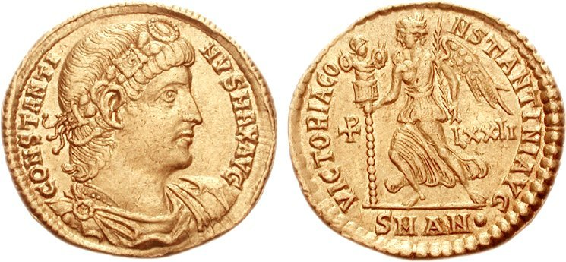

THE NICENE CREED
Responses: C: We believe in one God,
the Father, the Almighty,
maker of heaven and earth,
of all that is, seen and unseen.
We believe in one Lord, Jesus Christ,
the only Son of God,
eternally begotten of the Father,
God from God, Light from Light,
true God from true God,
begotten, not made,
of one Being with the Father;
through him all things were made.
For us and for our salvation
he came down from heaven,
was incarnate of the Holy Spirit and the Virgin Mary
and became truly human.
For our sake he was crucified under Pontius Pilate;
he suffered death and was buried.
On the third day he rose again
in accordance with the Scriptures;
he ascended into heaven
and is seated at the right hand of the Father.
He will come again in glory
to judge the living and the dead,
and his kingdom will have no end.
We believe in the Holy Spirit, the Lord, the giver of life,
who proceeds from the Father and the Son,
who with the Father and the Son
is worshiped and glorified,
who has spoken through the prophets.
We believe in one holy catholic* and apostolic church.
We acknowledge one baptism
for the forgiveness of sins.
We look for the resurrection of the dead,
and the life of the world to come. Amen.
THE PRAYERS OF THE CHURCH
Hosanna
C: Save us!

THE LORD’S PRAYER
THE BLESSING
P: Go now and follow Christ in obedience. Have the same mind as was in Christ Jesus; Be humble, even in the face of hostility and do not turn back from following Jesus all the way to the cross.
P: May God bless you and keep you in his steadfast love; may Christ Jesus strengthen you to walk the way of the cross; and may the Holy Spirit fill you with the risen presence of Jesus Christ, now and always.
C: Amen.

