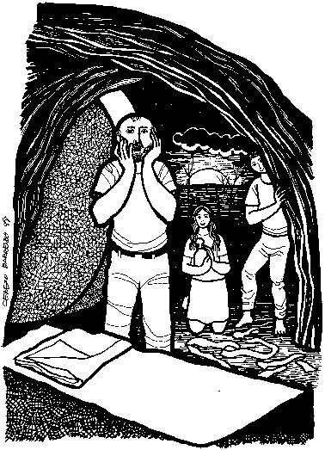

CALL TO WORSHIP: Christ is Risen, Alleluia Vocal Ensemble
ENTRANCE HYMN “Jesus Christ Is Risen Today”
Jesus Christ is risen today, Alleluia!
Our triumphant holy day, Alleluia!
Who did once, upon the cross, Alleluia!
Suffer to redeem our loss, Alleluia!
Hymns of praise then let us sing, Alleluia!
Unto Christ, our heavenly King, Alleluia!
Who endured the cross and grave, Alleluia!
Sinners to redeem and save, Alleluia!
But the pain which He endured, Alleluia!
Our salvation hath procured, Alleluia!
Now above the sky He's king, Alleluia!
Where the angels ever sing, Alleluia!
Sing we to our God above, Alleluia!
Praise eternal as His love, Alleluia!
Praise Him, all you heavenly host, Alleluia!
Father, Son, and Holy Ghost, Alleluia!

PROCESSION WITH THE PASCHAL CANDLE
RESURRECTING THE ALLELUIAS
EASTER DIALOGUE
P: Hold your head high, Christ has risen!
C: Rejoice and shout, Christ has come calling us home.
P: Home to the heart of God,
C: Home to God’s living presence, home to God’s banquet feast.
P: Hold your head high, Christ has risen!
C: Death has been conquered,
P: Christ has come calling us home.
C: All that was broken has been made whole, All that was dislocated has been set right, All that was oppressed has been set free.
P: Hold your head high, Christ has risen, bringing God’s healing,
C: Christ has come calling us home.
P: Redemption is complete,
C: God’s eternal world has begun,
P: Love reigns over all,
C: Alleluia, Alleluia, Alleluia! Christ has risen calling us home.
PRAYER OF THE DAY
P: The Lord be with you.
C: And also with you.
P: Holy and Living God,
C: like a tomb’s darkness that gives way to light, open us this day to newness of life; open us to your love, to your acceptance, to your forgiveness, to your peace; open us to one another, and to the possibilities you have in store for us. Give us hope for the future and a passion for life here and now. We pray in the name of the One who destroyed death, and in rising, renewed our life, Jesus Christ, our Savior. AMEN
FIRST READING: Colossians 3:1-4
1 If you have been raised with Christ, seek the things that are above, where Christ is, seated at the right hand of God. 2Set your minds on things that are above, not on things that are on earth, 3 for you have died, and your life is hidden with Christ in God. 4When Christ who is your life is revealed, then you also will be revealed with him in glory.
Word of God, Word of life!
C: Thanks be to God!
THE GOSPEL: Matthew 28:1–10
After the sabbath, as the first day of the week was dawning, Mary Magdalene and the other Mary went to see the tomb. 2And suddenly there was a great earthquake; for an angel of the Lord, descending from heaven, came and rolled back the stone and sat on it. 3His appearance was like lightning, and his clothing white as snow. 4 For fear of him the guards shook and became like dead men. 5But the angel said to the women, "Do not be afraid; I know that you are looking for Jesus who was crucified. 6He is not here; for he has been raised, as he said. Come, see the place where he lay. 7 Then go quickly and tell his disciples, 'He has been raised from the dead, and indeed he is going ahead of you to Galilee; there you will see him.' This is my message for you." 8So they left the tomb quickly with fear and great joy, and ran to tell his disciples. 9Suddenly Jesus met them and said, "Greetings!" And they came to him, took hold of his feet, and worshiped him. 10Then Jesus said to them, "Do not be afraid; go and tell my brothers to go to Galilee; there they will see me."
The Gospel of the Lord.
C: Praise to you, O Christ!
SERMON “Easter As An Earthquake”
THE NICENE CREED
C: We believe in one God,
the Father, the Almighty,
maker of heaven and earth,
of all that is, seen and unseen.
We believe in one Lord, Jesus Christ,
the only Son of God,
eternally begotten of the Father,
God from God, Light from Light,
true God from true God,
begotten, not made,
of one Being with the Father;
through him all things were made.
For us and for our salvation
he came down from heaven,
was incarnate of the Holy Spirit and the Virgin Mary
and became truly human.
For our sake he was crucified under Pontius Pilate;
he suffered death and was buried.
On the third day he rose again
in accordance with the Scriptures;
he ascended into heaven
and is seated at the right hand of the Father.
He will come again in glory
to judge the living and the dead,
and his kingdom will have no end.
We believe in the Holy Spirit, the Lord, the giver of life,
who proceeds from the Father and the Son,
who with the Father and the Son
is worshiped and glorified,
who has spoken through the prophets.
We believe in one holy catholic* and apostolic church.
We acknowledge one baptism
for the forgiveness of sins.
We look for the resurrection of the dead,
and the life of the world to come. Amen.
THE PRAYERS OF THE CHURCH
Alleluia!
C: Christ is risen!

THE LORD’S PRAYER

BLESSING AND SENDING
P: Go out into the world in the joy and peace of the resurrection of the Lord Jesus.

P: Care for his redeemed creation; follow him as children of the light; make disciples by your life and words; and glorify him by your dedication and love; so may he bless you with his gift of his life giving Spirit now until his kingdom comes.
C: Alleluia. Amen.

