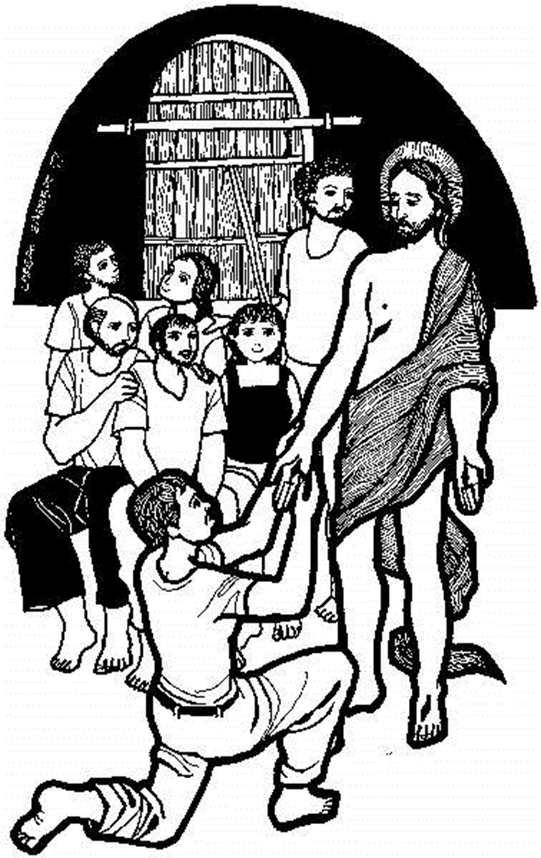

CALL TO CONFESSION
P: The risen Christ has come here to meet us where we are. He breathes the Holy Spirit upon us, and calls on us to confess our sins, and receive the gift of forgiveness that we may have peace.
C: Thanks be to God! Amen.

PRAYER OF CONFESSION

--Silence for Reflection--

P: God of Life and Death:
C: We have come through the joy of Easter, the triumphant Easter songs, and shouts of Alleluia! Yet we doubt, Lord. We want to be faithful, but sometimes we
have great difficulty believing in the power of life and hope to overcome death, disease, loss and despair. This day, like Thomas, we confess our doubts. In the aftermath of the grand Easter celebration, we have slipped back into old ways, and the gloom of daily news reports weigh us down. Shine your light of joy and life on us and lighten our dark path. We know that to doubt is human. Help us to believe, even though we have not seen you, touched your hands and side. Help us this second Sunday of Easter to live and believe the truth:
P: Christ is risen!
C: He is risen indeed! Alleluia! Alleluia! Amen!

P: Jesus says, “Peace be with you!” Hear the good news, Jesus Christ has been raised from the dead, and through love and grace has returned to the disciples who betrayed and deserted him. His return to be with us declares his forgiveness of our sins, our doubts and our many failings. Furthermore, he promises to be with us always! Rejoice, you have the forgiveness of your sins and the promise of new life through our risen Lord Jesus!
C: Amen. Alleluia! Alleluia!

Opening song: Now the Feast and Celebration Marty Haugen
Pam Asberry, pianist
GREETING
P: We come as we are:
C: We are doubting Thomases, fearful disciples,
sorrowing exiles, rejoicing psalmists!
P: You come as you are:
C: Risen Christ, Christ of peace,
Holy Spirit, Spirit of forgiveness,
God of life, God of new birth!
P: Come into our presence. Make yourself
known among us.
C: That we who have not seen may be given what we need
to believe and worship you our Lord and our God!

PRAYER OF THE DAY

A; The Lord be with you.
C: And also with you.

C: It seems so long ago that we stood in this
worship space, and shouted “Christ is risen!”
Stand among us once again this day, risen Christ,
and reassure us with your presence.
Stand among us once again, Exalted Brother,
and breathe upon us your promised Spirit.
Stand among us once again,
you who have escaped death,
and give us new birth
into your living hope. Amen.

FIRST READING: 1 Peter 1:3-9

³Blessed be the God and Father of our Lord Jesus Christ! By his great mercy he has given us a new birth into a living hope through the resurrection of Jesus Christ from the dead, ⁴and into an inheritance that is imperishable, undefiled, and unfading, kept in heaven for you, ⁵who are being protected by the power of God through faith for a salvation ready to be revealed in the last time. ⁶In this you rejoice, even if now for a little while you have had to suffer various trials, ⁷so that the genuineness of your faith—being more precious than gold that, though perishable, is tested by fire—may be found to result in praise and glory and honor when Jesus Christ is revealed. ⁸Although you have not seen him, you love him; and even though you do not see him now, you believe in him and rejoice with an indescribable and glorious joy, ⁹for you are receiving the outcome of your faith, the salvation of your souls.

Word of God, Word of Life!
C: Thanks be to God!

John 20:19-31

¹⁹When it was evening on that day, the first day of the week, and the doors of the house where the disciples had met were locked for fear of the Jews, Jesus came and stood among them and said, "Peace be with you." ²⁰After he said this, he showed them his hands and his side. Then the disciples rejoiced when they saw the Lord. ²¹Jesus said to them again, "Peace be with you. As the Father has sent me, so I send you." ²²When he had said this, he breathed on them and said to them, "Receive the Holy Spirit. ²³If you forgive the sins of any, they are forgiven them; if you retain the sins of any, they are retained." ²⁴But Thomas (who was called the Twin), one of the twelve, was not with them when Jesus came. ²⁵So the other disciples told him, "We have seen the Lord." But he said to them, "Unless I see the mark of the nails in his hands, and put my finger in the mark of the nails and my hand in his side, I will not believe." ²⁶A week later his disciples were again in the house, and Thomas was with them. Although the doors were shut, Jesus came and stood among them and said, "Peace be with you." ²⁷Then he said to Thomas, "Put your finger here and see my hands. Reach out your hand and put it in my side. Do not doubt but believe." ²⁸Thomas answered him, "My Lord and my God!" ²⁹Jesus said to him, "Have you believed because you have seen me? Blessed are those who have not seen and yet have come to believe." ³⁰Now Jesus did many other signs in the presence of his disciples, which are not written in this book. ³¹But these are written so that you may come to believe that Jesus is the Messiah, the Son of God, and that through believing you may have life in his name.

P The Gospel of the Lord
C: Praise to you, O Christ!
A SERMON FOR CHILDREN OF ALL AGES
SERMON “Low Sunday”
Special Music: The Great Storm is Over John McCutcheon
Debby Brady, soloist
NICENE CREED
C: We believe in one God, the Father, the Almighty, maker of heaven and earth, of all that is, seen and unseen.
We believe in one Lord, Jesus Christ, the only Son of God, eternally begotten of the Father, God from God, Light from Light, true God from true God, begotten, not made, of one Being with the Father. through him all things were made. For us and for our salvation he came down from heaven; by the power of the Holy Spirit he became incarnate from the virgin Mary, and was made man. For our sake he was crucified under Pontius Pilate; he suffered death and was buried. On the third day he rose again in accordance with the Scriptures; he ascended into heaven and is seated at the right hand of the Father. He will come again in glory to judge the living and the dead, and his kingdom will have no end.
We believe in the Holy Spirit, the Lord, the giver of life, who proceeds from the Father and the Son. With the Father and the Son he is worshiped and glorified. He has spoken through the prophets. We believe in one holy catholic and apostolic Church. We acknowledge one Baptism for the forgiveness of sins. We look for the resurrection of the dead, and the life of the world to come. Amen

THE PRAYERS OF THE CHURCH
A: Our Lord and God,
C: Hear our prayers.

THE LORD’S PRAYER

BLESSING

P In great mercy, God, has given us a new birth
into a living hope,
for it is the risen Christ
who stands in our midst and says,
“Peace be with you!”
We go forth to walk the path of new life
and living hope.
And may the peace of the risen Christ be with us all!
C: Amen.

